A verseny fővédnöke:
Budapest Főváros XVII. kerület
Rákosmente Önkormányzata alpolgármestere
HORVÁTH TAMÁS

/60
Kitöltő kódja:

XVII. KERÜLETI ANGOL VERSENY – ÍRÁSBELI FORDULÓ
…5….. évfolyam
…………. kategória

- Circle the correct answer. / Karikázd be a helyes válasz betűjelét.

- Richard and I …… friends.
- is b. am c. has d. are

- Bob and Jack are …… .
- English b. France c. Russia d. Greece

- „What is …… name?” „Caroline. She is my cousin.”
- your b. his c. her d. its

- „…… is your mother’s dentist? „Mr. Chopper.”
- What b. Who c. How d. Where

- ……. the children from Baker street.
- This is b. That are c. These are d. Those is

- We …… a new English teacher. I hope she’s nice.
- have b. has c. do d. meet

- What’s your …… job? He is a lawyer.
- wife’s b. daughter c. husband’s d. son

- She can speak Italian …… she can’t speak French.
- because b. or c. while d. but

- Do you live in a flat?
- Yes, I live. b. Yes, I do. c.Yes, I am. d. Yes, I does.

- Are there any dogs in the park? ……
- Yes, there are. b. Yes, they are. c. Yes, dogs are. d. Yes, it is.

10

- Match column A and column B. / Párosítsd a két oszlop mondatrészeit.

- We want to travel to Egypt … a. very dangerous.
- She is a nurse and … b. drink coffee.
- There aren’t any horses … c. she works in a hospital.
- You can see trains … d. is five pounds.
- Children like … e. by plane.
- A crocodile is … f. can drive very well.
- My uncle … g. playing.
- They go fishing … h. at the railway station.
- My mother doesn’t … i. go skiing.
- I have got a … j. at the weekend.
k. lot of friends.
l. in the stable.
1.___ 2.___ 3.___ 4.___ 5.___ 6.___ 7.___ 8.___ 9.___ 10.___

10

- Answer the questions. / Adj egész mondatos választ a kérdésekre.

- How many cousins heve you got?

………………………………………………………………………………….
- Where do you live?

………………………………………………………………………………….
- When is your birthday?

………………………………………………………………………………….
- What colour are your friend’s eyes?

………………………………………………………………………………….
- What can fish do?

………………………………………………………………………………….

5

- Vocabulary task. / Nevezd meg a képen látható dolgokat.

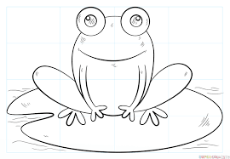

1…………………….

2…………………………….
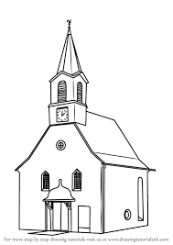
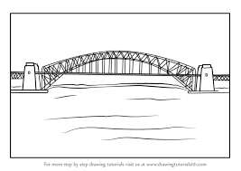

3…………………………………………… 4………………………………………...
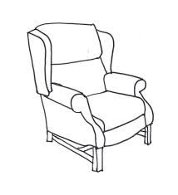

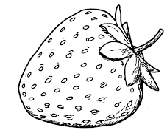
5…………………………………………. 6…………………………………………….

7……………………………………... 8…………………………………………………

9……………………………………………. 10…………………………………………
- Fill in the gaps. There are two extra words. / Egészítsd ki a szöveget a megadott szavakkal. Kettő szó fölösleges.

going a and at on but do is she there they to

Ann lives with her family in a city called Kent in the UK. She is 12 years old.
…............. (1) are four people in her family, her dad, mum and brother. Ann goes …………… (2)school. It is ……………. (3) nice little school and Ann has a lot of friends there.

Ann’s favourite hobby ……………. (4) cycling. She is quite good at it. ……………. (5) Saturdays she goes cycling with her family. Her mum …………….. (6) dad really like cycling, too. ……………. (7) love going out together.

Ann goes to a cycling club twice a week. Some of her friends …………….. ((8) not like cycling very much …………….. (9) Ann does. Today she is …………….. (10) to a race. She wants to win, so she is very excited.
10

- Put questions to the underlined words. / Tegyél fel kérdéseket az aláhúzott szavakra.

- There are twenty chairs in the classroom.

…………………………………………………………………………………
- Jack doesn’t like rats.

…………………………………………………………………………………
- Mother’s Day is in May.

…………………………………………………………………………………
- The castle is behind the trees.

…………………………………………………………………………………
- She is very well today.

…………………………………………………………………………………..

5

7.Read the text and tick TRUE, FALSE or DOESN’T SAY. / Olvasd el a szöveget és jelöld: IGAZ, HAMIS vagy NINCS a szövegben.

Meet the Duggars

They drink seven litres of milk a day, and eat over one hundred and fifteen eggs every week. They are the biggest family in America.
Jim and Michelle Duggar have got eighteen children, ten sons and eight daughters, including two pairs of twins.
All their children have got names starting with the letter „J”. The children sleep in huge bedrooms in a very big home. It has got nine bathrooms.
They’ve got a lot of work to do in the house. The children help out. The older children help the younger ones.
Michelle teaches the younger family members at home. The eldest boys and girls learn at school.
The children can only watch family shows on TV. The house has got ten computers but only one has got access to the Internet. „The computers are for studying”, says Jim, „and there is no Youtube.”
They go shopping and on trips in the family bus. It’s got twenty-one seats.
The Duggars need no help with money, Bob has a good job. He says: „Our children haven’t got a lot of material things, but they have a loving home. „

 |  | True | False | Doesn’t say
1. | The twins are boys.
2. | Every child learns at home from the mother
3. | One of the girls is called Sophie.
4. | The children don’t watch action films.
5. | The family listens to music on the Internet.
6. | The father drives a bus.
7. | The family has more cars.
8. | The mother works as a teacher.
9. | Their home has got nine bedrooms.
10. | The children learn on the computer.

10

